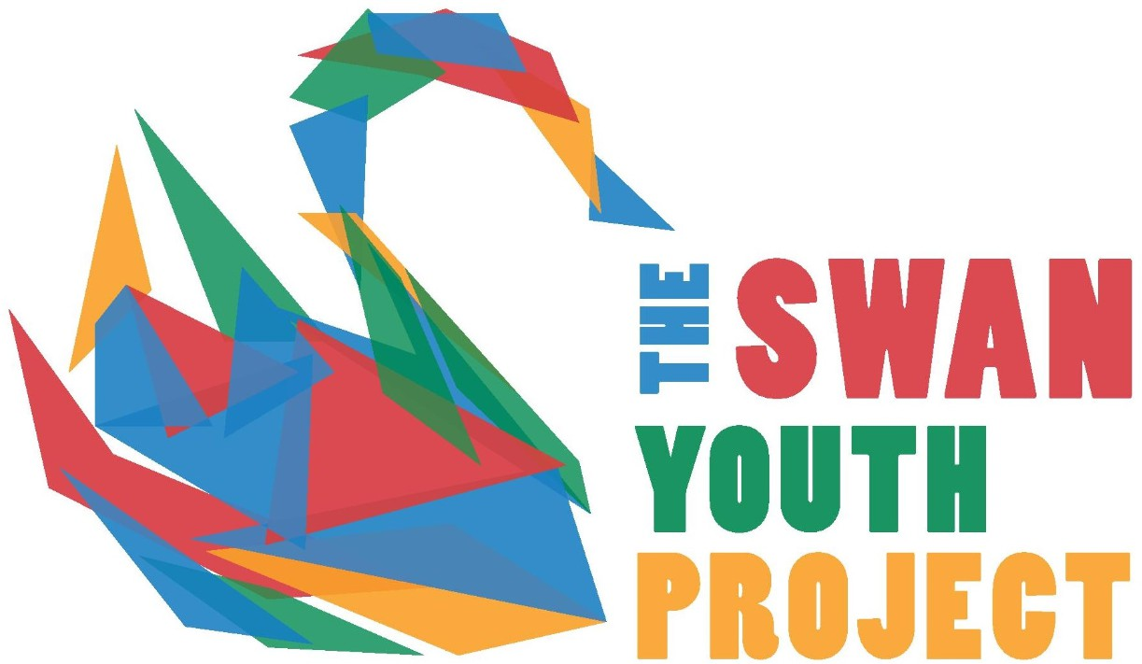
THE SWAN YOUTH PROJECT MEMBERSHIP AND CONSENT FORM 2025 TO 2026

This form needs to be completed by a parent/guardian and signed by both the child wishing to become a Swan member, and the parent/guardian completing the form. The form must be fully completed with all the relevant details.

CHILD DETAILS:
FIRST NAME: | PREFERRED NAME: | SURNAME: | GENDER:  (Male/Female/Non-B)
ADDRESS: |  | POSTCODE:
DATE OF BIRTH: |  | CHILD’S MOBILE NUMBER:
CHILD’S EMAIL:
SCHOOL AND CURRENT YEAR GROUP:

CHILD MEDICAL DETAILS:
Any specific medical conditions, which may require treatment (if yes please give details)
Any regular medication? | Do you have any allergies? If yes please give details
Any dietary requirements? | Is there anything else we should know?

PARENT/GUARDIAN DETAILS
FIRST NAME: | SURNAME: |  | YOUR RELATIONSHIP TO THE CHILD:
MOBILE: |  | EMAIL:

CHILD AGREEMENT
The information I have given is to the best of my knowledge correct. I agree to abide by the rules of The Swan Youth Project and will also complete the Swan induction.
Your Signature: | Date:

PARENTAL CONSENT
In the unlikely event of a medical emergency, I am willing for my child to receive medical care from a medical professional or a trained first aider.

YES / NO
I am happy for The Swan Youth Project to use photos and videos of my child in promotional materials, funding applications, the Swan Youth Project website and other social media. (A member's name will never be included)
YES / NO
In signing this member consent form, I agree that I know where I can find the Swan Youth Projects safeguarding and complaints policies on our website at www.swanyouthproject.co.uk. Furthermore, that I am aware that I can contact the Swan Youth Project’s manager Parul Dix for any safeguarding concerns or complaints by emailing manager@swanyouthproject.co.uk
Parent/Guardian Signature: | Date:

FOR INTERNAL USE ONLY: T1 / T2 / T3

Data Protection: The information provided by members and parents/guardians will be used in accordance with current data protection legislation. We may use your contact details to inform you about activities including fundraising events for The Swan. We do not make personal data available to other organisations unless a specific safeguarding issue has been identified and it is in line with Child Protection protocols

